2024-2025 OFFICERS

President
Kenneth Figgs

Vice President
Laurie Newell

Treasurer
Michael Gorman

Secretary
Christine Vespe

Historian
Alease Griffith

Immediate Past President
Dolores Szymanski.

Executive Committee
George Rafferty
Amy Stella
Fidelia Sturdivant

Awards Coordinator
Jay Dugan

Continuity Advisor
Cheryl L. Simone
Martin Smith

Program Consultant
Jay Doolan

Liaisons
Kenneth D. King – NJASA
Patricia Wright – NJDOE & NJPSA

MAILING ADDRESS:
New Jersey Council of Education
PO Box 254
Pompton Lakes, NJ 07442
MEETING SCHEDULE
2024-2025

GENERAL MEMBERSHIP
Friday, October 4, 2025
Forsgate Country Club
Monroe Township, NJ

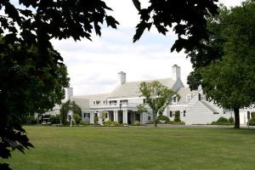

Friday, April 11, 2025
Forsgate Country Club
Monroe Township, NJ

Executive Committee

Monday, August 12, 2024
Thursday, November 14, 2024
Wednesday, January 15, 2025
Thursday, May 15, 2025

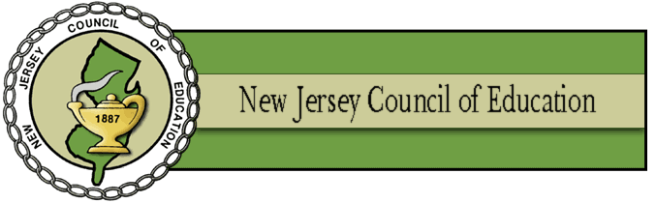

AN ORGANIZATION DEDICATED TO ENHANCING THE
PUBLIC SCHOOLS OF
NEW JERSEY

www.njcoe.org

The New Jersey Council of Education was established over 125 years ago as a “cadre of eminent educators” to promote the cause of public education in New Jersey. The Council provides a forum for thoughtful discussion of educational issues and the corresponding social, economic and political conditions and policies which set the framework for implementing effective education.



The Council remains a statewide organization which encompasses education at all levels including elementary, secondary, and college. It brings together professionals with the roles of school administrator, college professor, and Department of Education emissary. It establishes an environment where members who have diverse backgrounds and experiences can participate in discussions of mutual interest and concern. The Council encourages the utilization of the experience and wisdom of those with decades of dedicated service by providing for associate membership of retired educators.





With a limited active membership of 300 persons, the persuasiveness of the Council has never been based upon numerical voting strength or political “clout.” Rather, the influence which the Council exerts is necessarily dependent upon the quality of its membership and consensus on good professional ideas which may emerge and be disseminated by individual practitioners.



From its inception, the Council has been guided by a Jeffersonian belief in the importance of an educated citizenry in a representative form of democratic government. The Council continues to evaluate its mission in terms of historical perspective, the existing knowledge base, and the rapid social and technological developments of our society. The membership remains at the ready to renew the organization and rededicate itself to meet the challenges ahead.



MEMBERSHIP
1. Members of the Council may propose candidates for admission to the Council by completing the form available at the NJCOE website (www.njcoe.com). The form must be completed by the sponsors.
2. Two active members must sign the membership proposal.
3. The prime sponsor will be notified as to the status of the application. It is the sponsor’s responsibility to keep the applicant informed.
4. Applications will remain active for three years. If the candidate has not been admitted to the Council during that period, the application will be returned to the sponsor.
5. To be eligible for membership, the applicants must have completed at least five years of experience in administration as defined by the categories listed in the Constitution. The last three years of this administrative experience must have occurred in New Jersey.
6. Email the application to the Chairs of the Membership Committee:

Cheryl Simone
Email: cherylsimone@comcast.net

